How can you calculate the total sales for each year using DAX?
Total Sales Per Year =
CALCULATE (
[Total Sales],
ALLEXCEPT ( Automobile, Automobile[ReportingYear] )
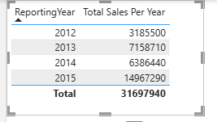

Create a measure to calculate the average sales per month.
Average Sales Per Month =
DIVIDE (
[Total Sales],
DISTINCTCOUNT ( Automobile[ReportingMonth] )
)
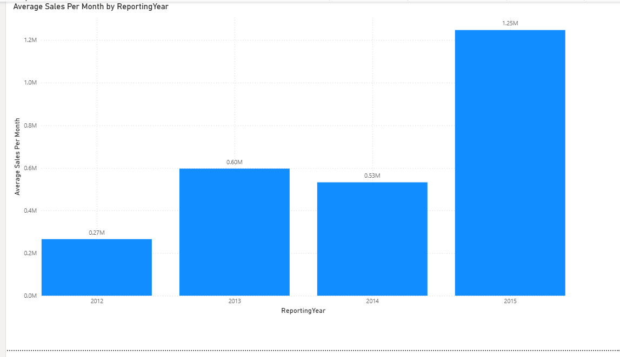

How would you create a cumulative total of sales over months?
Cumulative Sales =
CALCULATE (
[Total Sales],
FILTER (
ALL ( Automobile ),
Automobile[InvoiceDate] <= MAX ( Automobile[InvoiceDate] )
)
)
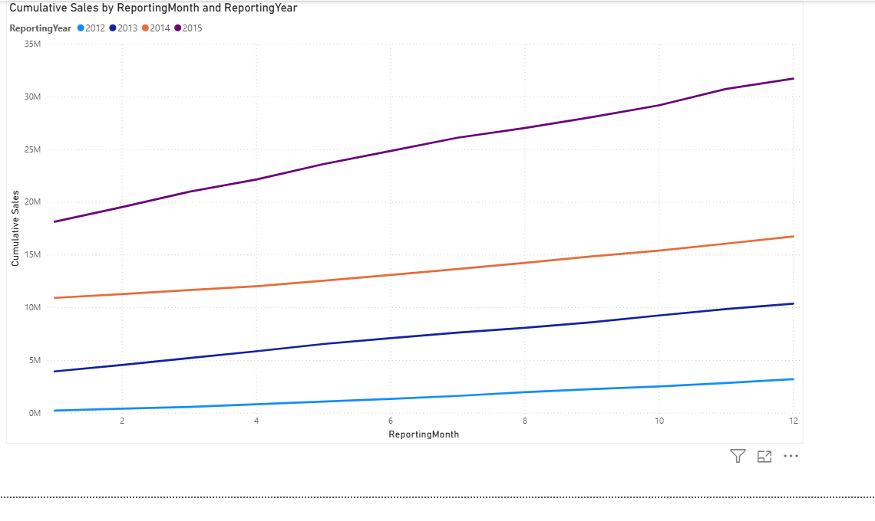
Write a DAX formula to calculate the Year-to-Date (YTD) sales

YTD Sales =
TOTALYTD (
[Total Sales],
Automobile[InvoiceDate]
)
How can you calculate the percentage growth in sales compared to the previous year?
Sales Growth % =
DIVIDE (
[Total Sales] - [Prior Year Sales],
[Prior Year Sales],
0
)
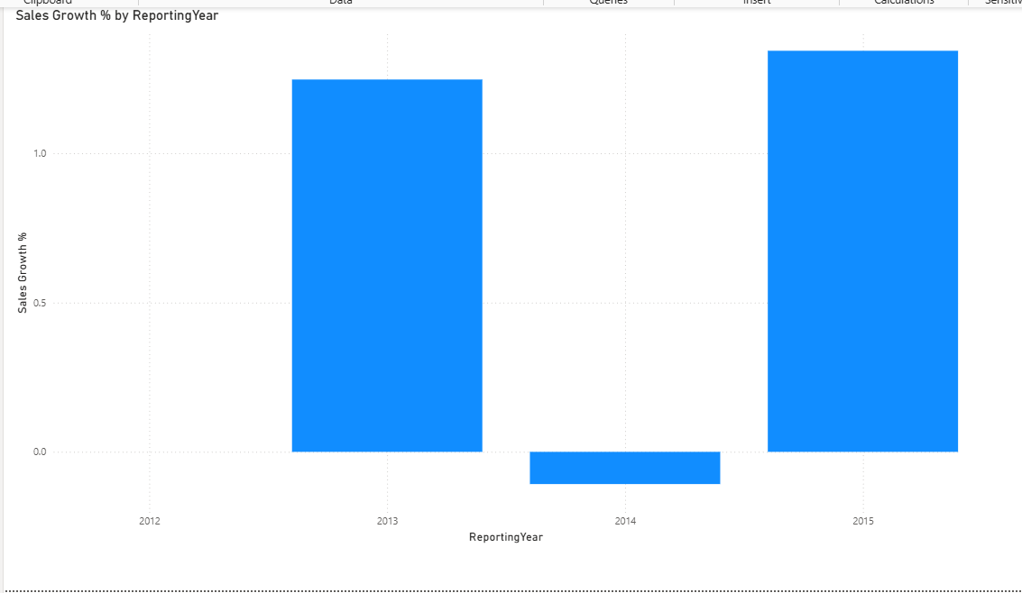

Create a measure to calculate the total sales for the last 12 months.
prior 12 Months Sales =
CALCULATE (
[Total Sales],
DATESINPERIOD (
Automobile[InvoiceDate],
MAX ( Automobile[InvoiceDate] ),
-12,
MONTH
)
)
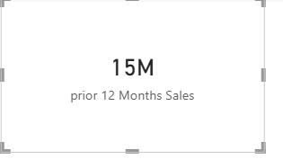

How would you calculate the highest sales month using DAX?
Highest Sales Month =
MAXX (
VALUES ( Automobile[ReportingMonth] ),
[Total Sales]
)
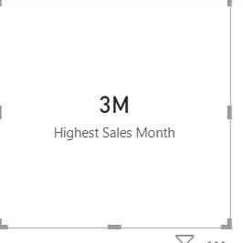

Write a DAX formula to find the top 5 selling products
Top5SellingProducts =
VAR ProductSales =
ADDCOLUMNS (
SUMMARIZE ( Automobile, Automobile[Model] ),
"TotalSales", SUM ( Automobile[SalePrice] )
)
RETURN
TOPN ( 5, ProductSales, [TotalSales], DESC )

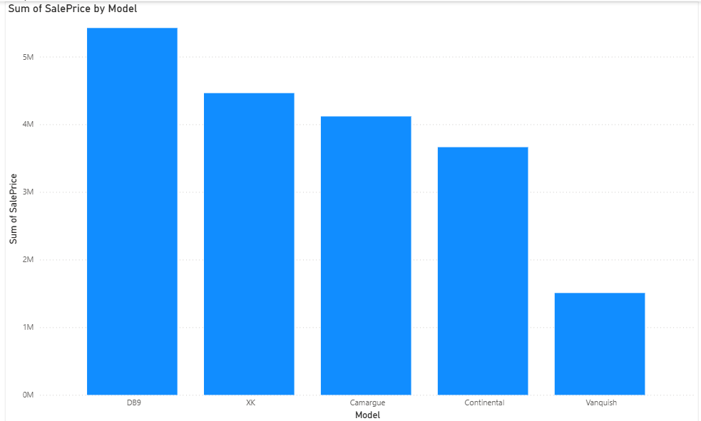
How can you calculate the sales contribution of each product category?
CategoryContribution =
DIVIDE ( [CategorySales], [Total Sales], 0 )
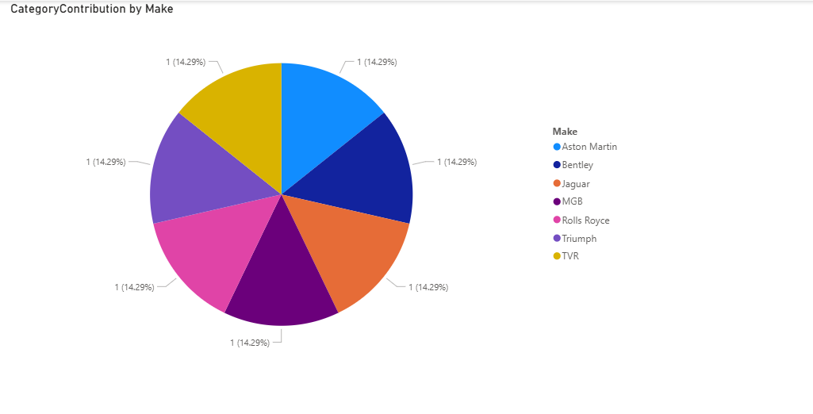
Create a measure to find the total sales where the sales amount is greater than a specific value.
TotalSalesAboveThreshold =
VAR Threshold = 50000 -- set your specific value here
RETURN
CALCULATE (
SUM ( Automobile[SalePrice] ),
Automobile[SalePrice] > Threshold
)
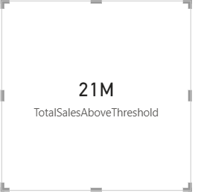
How can you calculate the running total of sales for each product?
RunningTotalSales =
CALCULATE (
[Total Sales],
FILTER (
ALLSELECTED ( Automobile[InvoiceDate] ),
Automobile[InvoiceDate] <= MAX ( Automobile[InvoiceDate] )
)
)

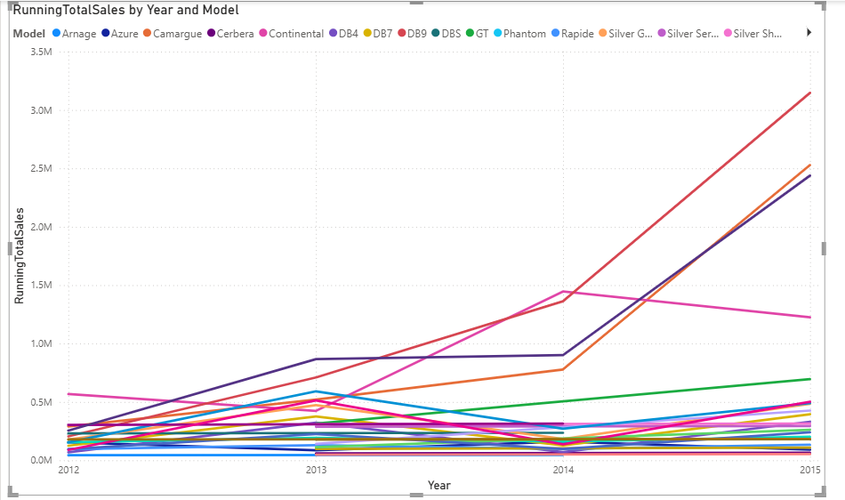

Write a DAX formula to calculate the average sales per customer
AvgSalesPerCustomer =
DIVIDE ( [Total Sales], [CustomerCount], 0 )
How would you calculate the total number of distinct customers?
TotalDistinctCustomers =
DISTINCTCOUNT ( Automobile[ClientName] )
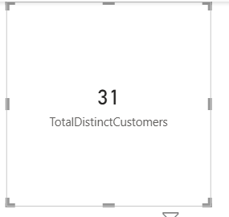
Create a measure to calculate the sales per region
SalesPerRegion =
CALCULATE (
[Total Sales],
ALLEXCEPT ( Automobile, Automobile[CountryName] )
)
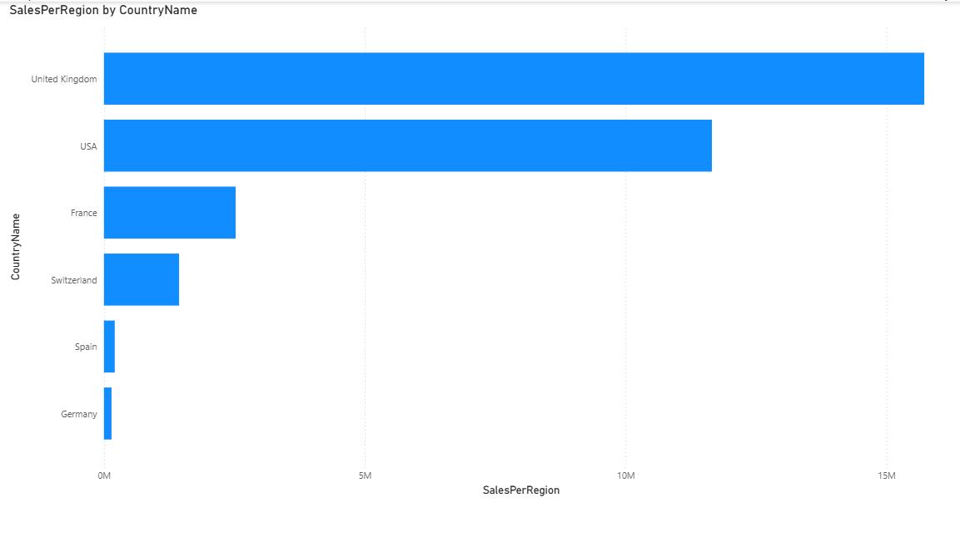

How can you calculate the moving average of sales over 3 months?
MovingAvg3Months =
AVERAGEX (
DATESINPERIOD (
Automobile[InvoiceDate],
MAX ( Automobile[InvoiceDate] ),
-3,
MONTH
),
[Total Sales]
)
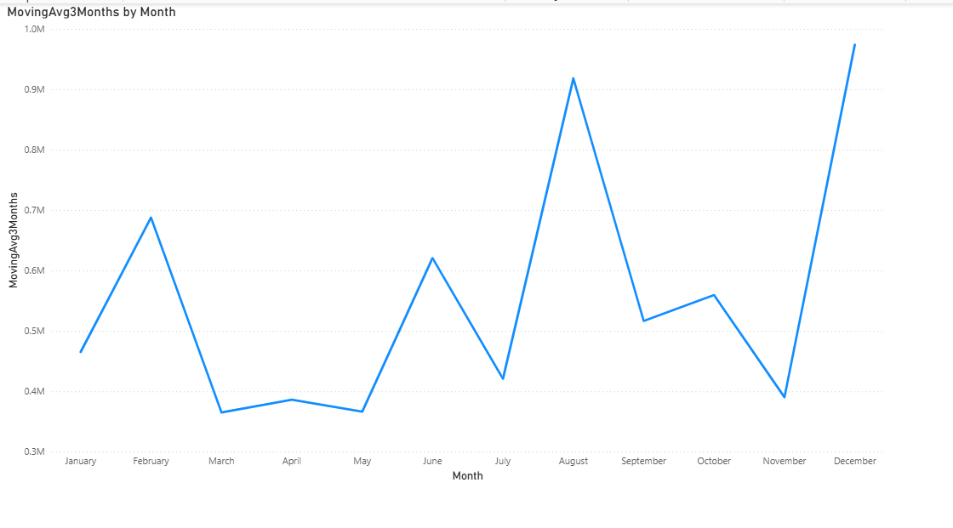
Write a DAX formula to filter sales data for a specific product category.
SalesForCategory =
CALCULATE (
SUM ( Automobile[SalePrice] ),
Automobile[VehicleType] = "Coupe"
)
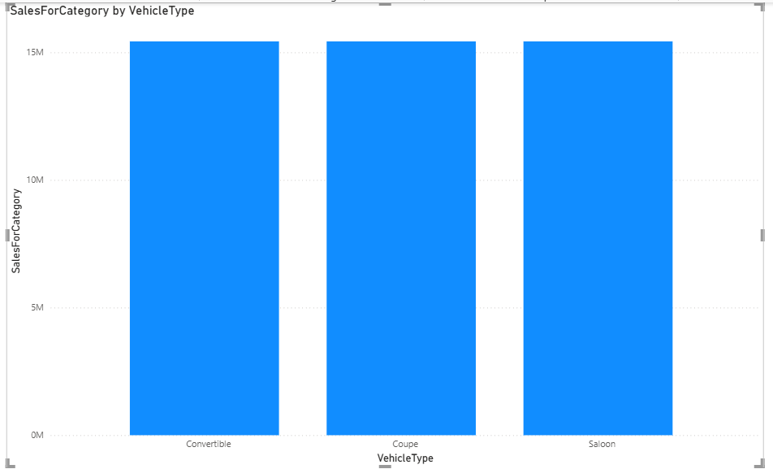

How can you calculate the sales variance compared to the budget?
SalesVariancePct =
DIVIDE ( [ActualSales] - [BudgetSales], [BudgetSales], 0 )
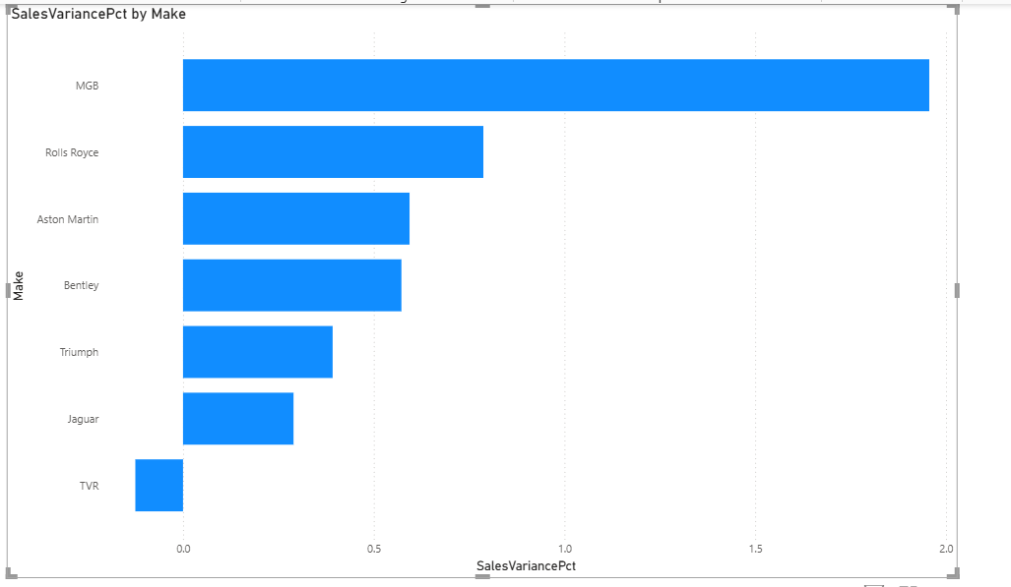
Create a measure to calculate the total profit margin
TotalProfitMargin =
DIVIDE (
SUM ( Automobile[SalePrice] ) - SUM ( Automobile[CostPrice] ),
SUM ( Automobile[SalePrice] ),
0
)
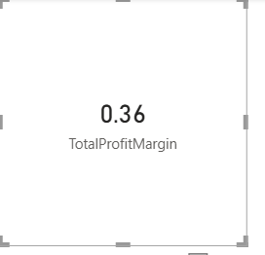
How would you calculate the sales rank of each product?
SalesRank =
RANKX (
ALL ( Automobile[Model] ),
[Total Sales],
,
DESC,
Dense
)
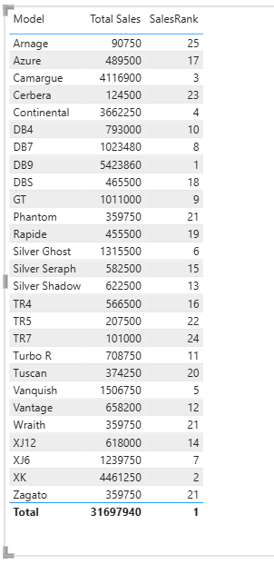

Write a DAX formula to calculate the total sales for a specific date range.
TotalSales_2013 =
CALCULATE (
SUM ( Automobile[SalePrice] ),
FILTER (
Automobile,
Automobile[InvoiceDate] >= DATE ( 2013, 1, 1 )
&& Automobile[InvoiceDate] <= DATE ( 2013, 12, 31 )
)
)
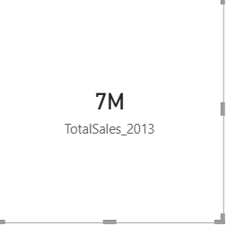
How do you filter the data to show only records where the Make is "Jaguar"?
JaguarCars =
FILTER (
Automobile,
Automobile[Make] = "Jaguar"
)
Select the Visual
Click on the chart, table, or matrix visual you want to filter.
- Open the Filters Pane
On the right-hand side of Power BI Desktop, you’ll see the Filters pane. It has sections for:
  - Visual level filters (applies only to the selected visual)
- Drag the Field into Filters
Drag the Make column into the Visual level filters section.
- Set the Filter Condition
  - In the filter options, select Basic filtering or Advanced filtering.
  - Choose Jaguar from the list of values.
- Confirm
The visual will now only display records where Make = "Jaguar"
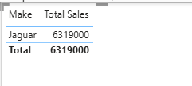
How can you remove the columns ClientName and LaborCost from the dataset?
- In Power BI Desktop, go to Home → Transform Data.
- In the Power Query Editor, select your table (Automobile).
- Highlight the columns ClientName and LaborCost.
- Right-click → Remove Columns.
- → This permanently excludes those columns from the dataset when it loads into the mode
How can you replace the values "Coupe" with "Convertible" in the VehicleType column?
- In Power BI Desktop, go to Home → Transform Data.
- In the Power Query Editor, select the VehicleType column.
- On the ribbon, choose Transform → Replace Values.
- Enter:
  - Value to Find: Coupe
  - Replace With: Convertible
- Apply changes and load the data back into Power BI.
This permanently replaces "Coupe" with "Convertible" in the dataset.
How can you add a new column that calculates the total cost (CostPrice + DeliveryCharge + SpareParts + LaborCost) for each record?
- Go to Home → Transform Data in Power BI Desktop.
- In the Power Query Editor, select your table (Automobile).
- On the ribbon, choose Add Column → Custom Column.
- Enter a formula like:
= [CostPrice] + [DeliveryCharge] + [SpareParts] + [LaborCost]
- Name the column TotalCost.
- Apply changes and load the data back into Power BI.
How can you split the InvoiceDate column into two separate columns: InvoiceYear and InvoiceMonth?
- Go to Home → Transform Data in Power BI Desktop.
- In the Power Query Editor, select the InvoiceDate column.
- On the ribbon, choose Add Column → Date → Year → this creates InvoiceYear.
- Then choose Add Column → Date → Month → Month → this creates InvoiceMonth.
- Apply changes and load the data back into Power BI.
How can you group the data by Make and CountryName to get the sum of SalePrice for each group?
- In Power BI Desktop, go to Home → Transform Data.
- In the Power Query Editor, select your table (Automobile).
- On the ribbon, choose Home → Group By.
- In the Group By dialog:
  - Group by: select Make and CountryName.
  - Operation: choose Sum.
  - Column: select SalePrice.
  - Name the new column TotalSalePrice.
- Click OK.
- → This creates a grouped table showing each combination of Make and CountryName with the total sales.
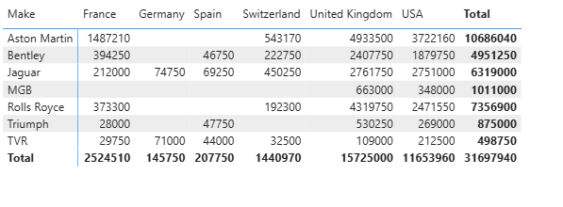
How can you sort the data by SalePrice in descending order?
- In Power BI Desktop, go to Home → Transform Data.
- In the Power Query Editor, select your table (Automobile).
- Click on the SalePrice column header to highlight it.
- On the ribbon, go to Home → Sort Descending (the ↓ icon).
- → This will reorder the rows so that the highest SalePrice values appear first.
- Click Close & Apply to save changes.
This permanently sorts the dataset before loading it into the model.
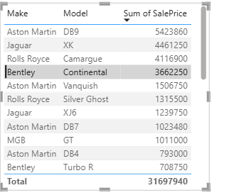
How can you merge this dataset with another table that contains additional ClientName information, using ClientName as the key?
Method 1: Relationships in Power BI Model
If you want to keep the tables separate but link them:
- Go to Model view in Power BI Desktop.
- Drag ClientName from the Automobile table to ClientName in the ClientDetails table.
- This creates a relationship (usually Many-to-One).
- Now you can use fields from both tables in visuals without physically merging them.
Method 2: DAX Lookup (Virtual Join)
If you want to pull in specific fields from the second table:
ClientInfo = LOOKUPVALUE ( ClientDetails[ExtraInfo], ClientDetails[ClientName], Automobile[ClientName] )
This adds a calculated column in Automobile that retrieves extra info based on ClientName.
How can you remove duplicate records based on the combination of InvoiceDate and Make?
- Load your dataset into Power BI.
- Go to Transform Data → this opens Power Query Editor.
- Select both columns: InvoiceDate and Make.
- On the ribbon, click Remove Duplicates.
- This keeps only the first occurrence of each unique (InvoiceDate, Make) pair.
- All other duplicates are removed.
How can you pivot the Color column so that each unique color becomes a new column and the values are the SalePrice?
- Load your dataset into Power BI.
- Go to Transform Data → opens Power Query Editor.
- Select the Color column.
- On the ribbon, choose Transform → Pivot Column.
- In the dialog:
  - Values Column → select SalePrice.
  - Aggregation → choose how to handle duplicates (e.g., Sum, Average, Max, Min).
- Result: Each unique color (Red, Blue, Green, etc.) becomes its own column, with SalePrice values filled in.

DAX Alternative (Dynamic Pivot)
If you prefer to keep the dataset unpivoted but want measures per color:
RedSales = CALCULATE( SUM(Automobile[SalePrice]), Automobile[Color] = "Red" ) BlueSales = CALCULATE( SUM(Automobile[SalePrice]), Automobile[Color] = "Blue" )
- Each measure corresponds to one color.
- You can then place these measures side by side in a table visual.
- Use Power Query Pivot if you want a reshaped dataset.
- Use DAX measures if you want a flexible reporting layer without altering the base table.
How can you create a bar chart to compare total sales by product category?
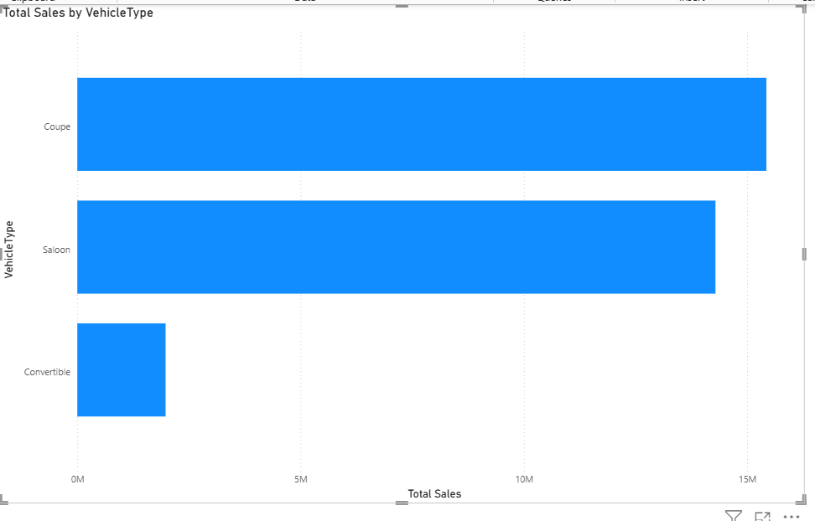
What steps would you take to create a line chart showing monthly sales trends
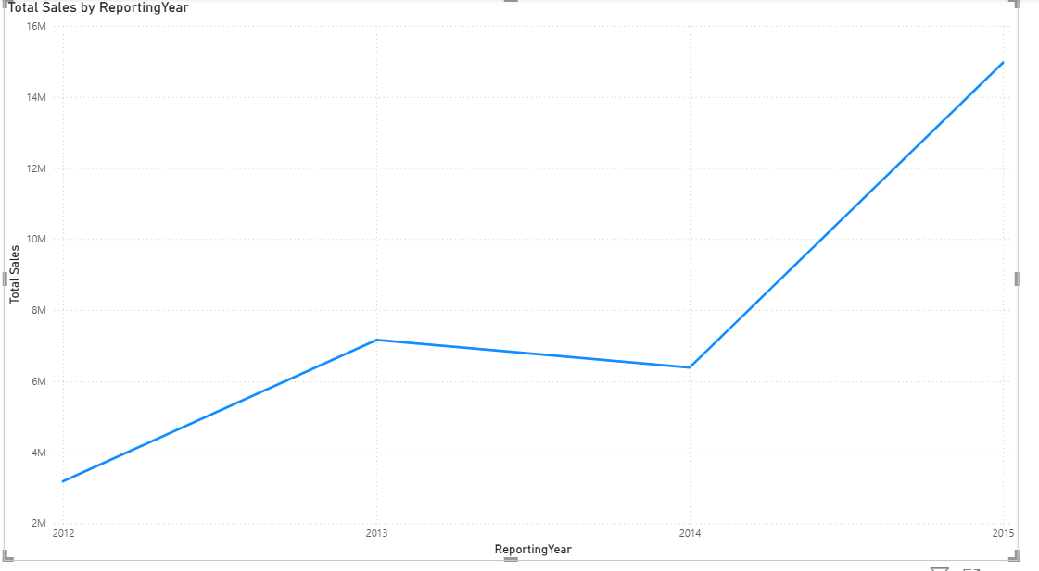
How can you use a pie chart to show the sales distribution by region
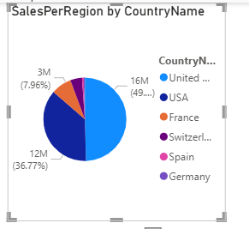
Create a scatter plot to visualize the relationship between sales and profit
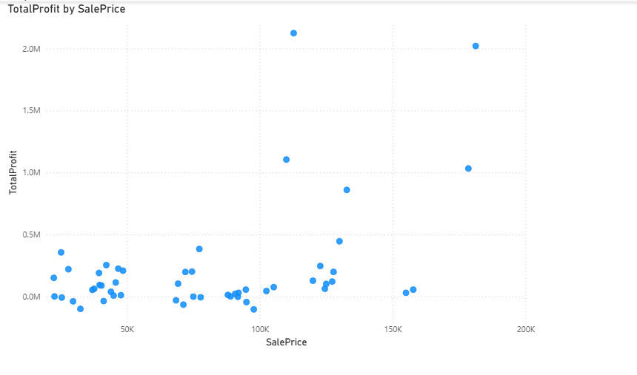
How can you add a trend line to a line chart to show sales growth over time?
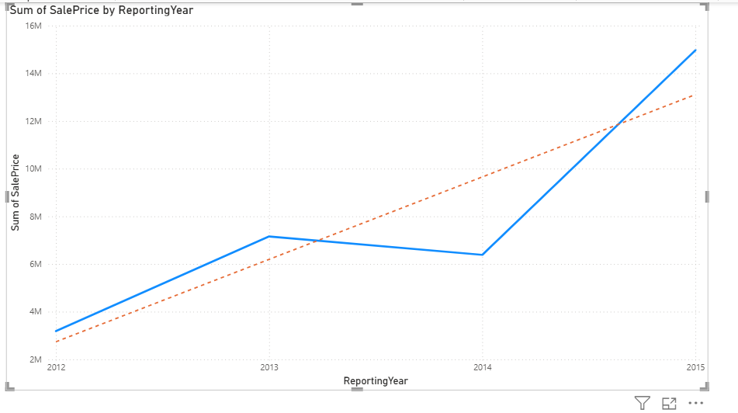
Select your Line Chart (e.g., showing SalePrice over ReportingYear or ReportingMonth).
- Go to the Visualizations pane → click on the Analytics icon (magnifying glass).
- Under Trend line, click Add.
- Customize:
  - Name → e.g., "Sales Growth Trend".
  - Color → choose a contrasting color.
  - Style → solid or dashed.
  - Transparency → adjust visibility.
- The chart now shows a regression-based trend line automatically
What is the process to create a stacked bar chart to show sales by product category and region?
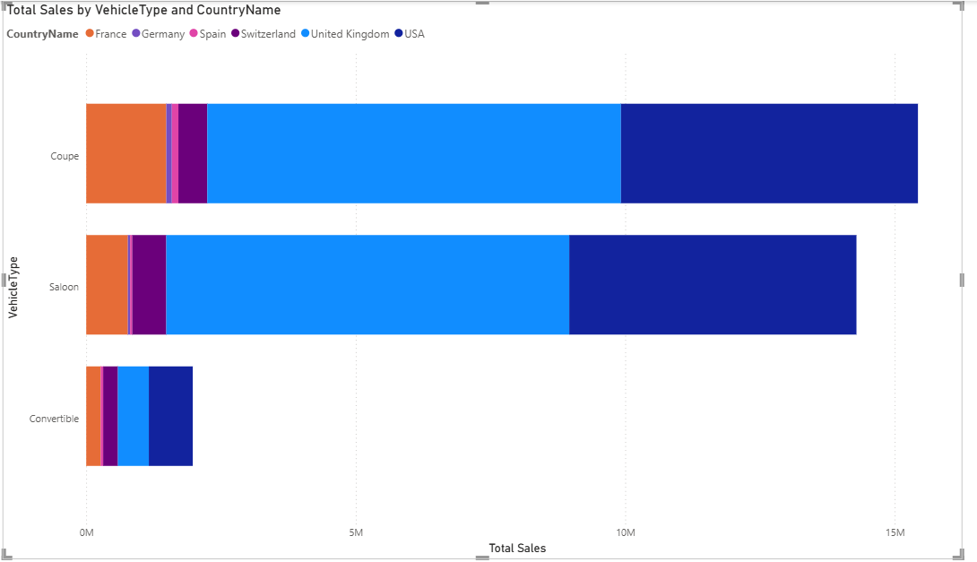

How can you use a map visualization to display sales data by geographic location?
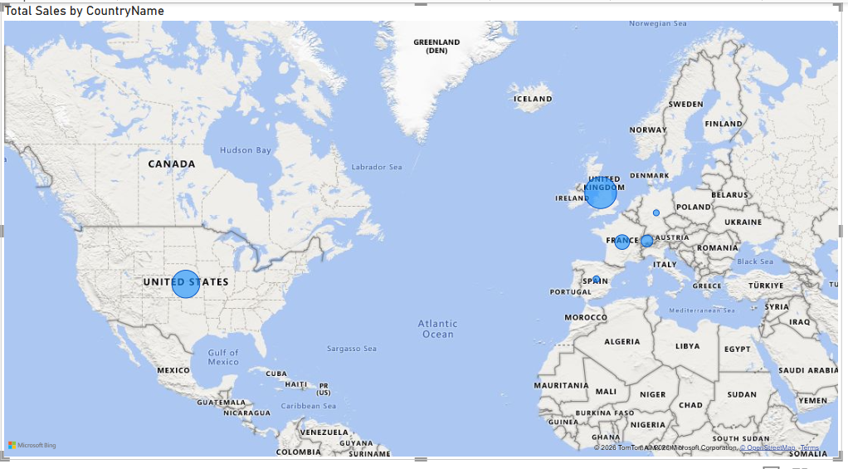

Create a heat map to show the intensity of sales across different regions
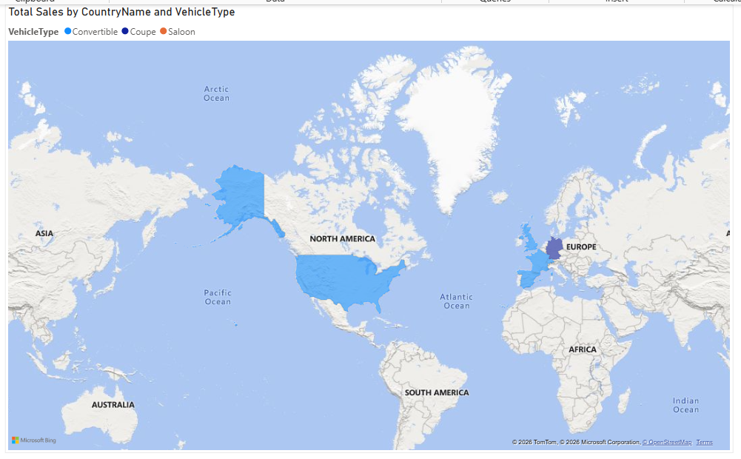
How can you use a tree map to visualize the sales contribution of each product category?
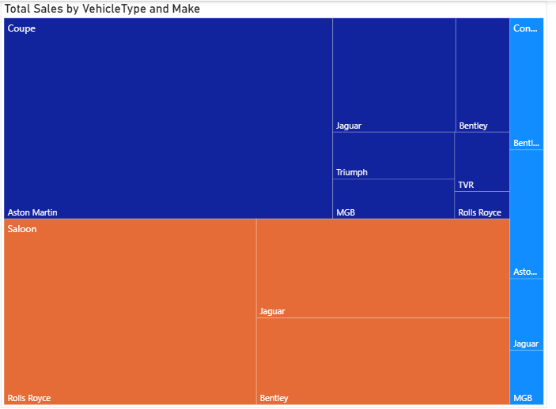
What steps would you take to create a waterfall chart to show sales variances?
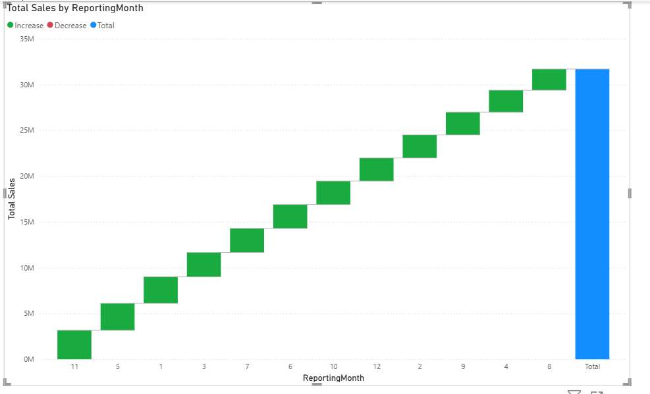
How can you create a KPI visual to display key sales metrics?
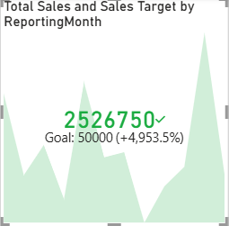
What is the process to create a funnel chart to visualize the sales pipeline?
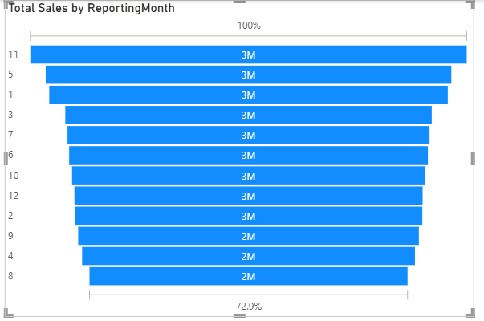
How can you use a gauge chart to show the performance against a sales target?
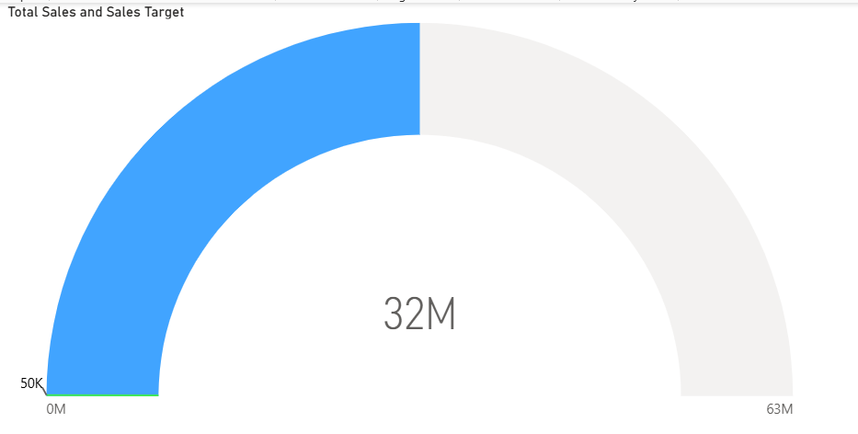
Create a histogram to show the distribution of sales amount.
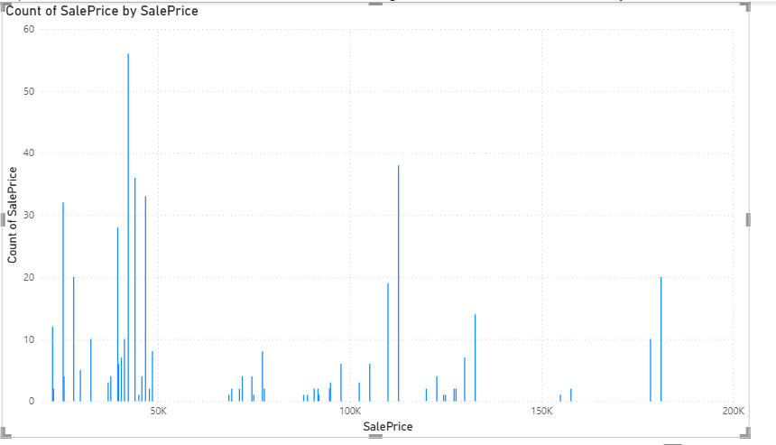
How can you use slicers to filter visualizations based on product categories?
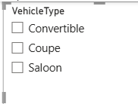
What steps would you take to create a combo chart to compare sales and profit?
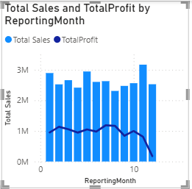
How can you use a card visual to display the total sales amount
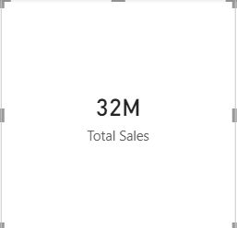
Create a bullet chart to compare actual sales against a target
I don’t have organisation account to sign in.
How can you use bookmarks to create a storytelling experience in Power BI?
• Set up your visuals
Arrange charts, tables, and KPIs to represent one stage of your story (e.g., "Overall Sales Growth").
- Create a Bookmark
  - Go to the View tab → Bookmarks Pane.
  - Click Add to save the current view.
  - Rename it (e.g., "Step 1 – Sales Overview").
- Adjust the View for Next Step
Change filters, highlight a specific product, or switch visuals to show the next part of the story (e.g., "Step 2 – Jaguar Sales").
- Add Another Bookmark
Save this new state as another bookmark.
- Use Buttons for Navigation
  - Insert a button or shape (Insert → Buttons).
  - Assign an Action → Bookmark.
  - This lets users click through your story like slides.
- Organize Bookmarks
- Use Bookmark Groups to keep related steps together.
- Enable Data, Display, Current Page options depending on what you want to capture.
What is the process to create a matrix visual to display sales data in a tabular format?
